Chapter 17, Solution 73.

p = 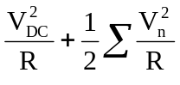

= 0 + 0.5[(2² + 1² + 1²)/10] = 300 mW

